**PROJECT REPORT TEMPLATE**

1. INTRODUCTION

The project aims to enhance the innovation and entrepreneurship skills of students through various project – based learning.

PURPOSE

A Single post can get viral and reach hundreds and thousands of people at the same time through their phones, all at the same time.

2. i) EMPATHY MAP:

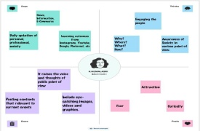

ii) BRAINSTORMING

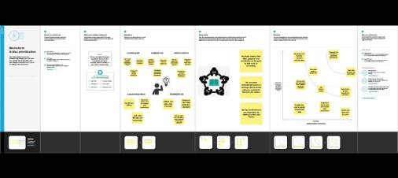

3. RESULT:



4. PROS:

* There is more opportunity to branch out among social media posts.
* Keeps people in touch and encourages creativity ideas

CONS:

* Destroys our self esteem.
* Creates unrealistic expectations.

5.APPLICATION:

These applications can accessible. These designs helps us to design our ideas in real.

6. CONCLUSION:

I learnt to design the social media post. This features can easy to design my ideas. It can reach all.